

Functional Specification Documentation

For
Automation Landed Cost

Version No.: 1.0
Date: 3rd March 2017

Table of Content
1. Overview Details 3
1.1 Objective 3
2. Table Setup (User Defined Table) 0
3. Requirement 2
Reports 6
Report #1 – Landed Cost Contract Account Reconciliation Report 6
Report #2 – Landed Cost with COS account report 6
Report #3 – Freight Percentage 6

1. Overview Details

1.1 Objective

Description
- When a Goods Receipt PO (GRPO) is added into SAP, a Landed Cost document will be created automatically for upon GRPO creation.
- For Actual landed cost, user need to create manually at Landed cost module.

Note:
ALC = Actual Landed Cost
ELC = Estimated landed cost

Pre-requisition

The automation landed cost will be activating only when below condition is match:
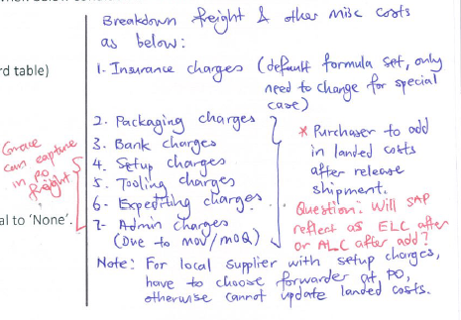
- Below table need to be configure firs:

  - Landed Cost – Setup (SAP Standard table)
  - Landed Cost Component
  - Courier Table
  - Forwarder table
  - Fuel Surcharge Table
  - Inco Table
  - Dimension Surcharge Table
  - Zone Table

- At GRPO screen, Landed Cost Method not equal to ‘None’.

Yes
Yes

2. Table Setup (User Defined Table)

- Landed Cost Component Table
If the component exists in this table, will be auto flow into Landed Cost.

 | Component | Type
 | Freight Charges (ELC) | ELC
 | Insurance Charge (ELC | ELC

- Courier Table

Forwarder code (BP code) | Weight (kg) | Zone 1 | Zone 2 | Zone 3 | Zone 7
DHL | 0.5 | 14.33
DHL | 1.0 | 15.58
DHL | 2.0 |  |  |  | 49.24
- Forwarder Table (always compare minimum and flat which higher then plus basic)

Forwarder | Country | Supplier  BP Code | Cur | Component | By Amount/Percent | By KG  /NET | Min | Flat | Basic | From Date | To Date
DHL Global | UK | ALL | GBP | Freight | Amount | KG | 20.00 | 1.20 | 0.00 | 01/01/2015 | 31/12/2015
DHL Global | UK | ALL | GBP | Fuel | Amount | KG | 0.00 | 1.50 | 0.00 | 01/10/2015 | 31/12/2015
DHL Global | UK | ALL | GBP | Handling | Amount | KG | 20.00 | 0.20 | 32.00 | 01/10/2015 | 31/12/2015
DHL Global | UK | ALL | GBP | Export Fee | Amount | KG | 15.00 | 0.00 | 0.00 | 01/10/2015 | 31/12/2015
DHL Global | UK | ALL | GBP | X-Ray | Amount | KG | 8.00 | 0.09 | 0.00 | 01/10/2015 | 31/12/2015
DHL Global | UK | ALL | SGD | Local Handling | Amount | KG | 60.00 | 0.20 | 0.00 | 01/10/2015 | 31/12/2015

- Fuel Surcharge Table

Courier | Country | By Amount/Percent | By KG /Net | Rate | Month
DHL |  | Percent | KG | 11.00 | October 2015 | 11% x Weight
FedEx |  | Amount | KG | 15.00 | October 2015 | $15 x weight
TNT |  | Amount | Net | 100 | October 2015 | $100

- Inco Table

Inco-term code | PO Print Out Description | CFR value | Insurance rate
EXW | EXW | 1.1 | 0.00025
CIF | CIF | 0 | 0
FCA-Overseas | FCA | 1.1 | 0.00025
FCA-Local | FCA | 0 | 0
FOB | FOB | 1.1 | 0.00025

- Dimension Surcharge Table

Forwarder/Courier | Extra Charge | Weight | Weight Surcharge | Dimension | Dimension Surcharge
DHL Express | Yes | 70 | 45 | 120 | 40
TNT |  | 70 | 41 | 120 | 41
DHL Global |  | 70 | 40 | 120 | 0

- Zone Table / make use of Country table

Country | DHL | TNT | FedEx
Singapore | 1 | 1 | 2
Australia | 3 | 3

Requirement

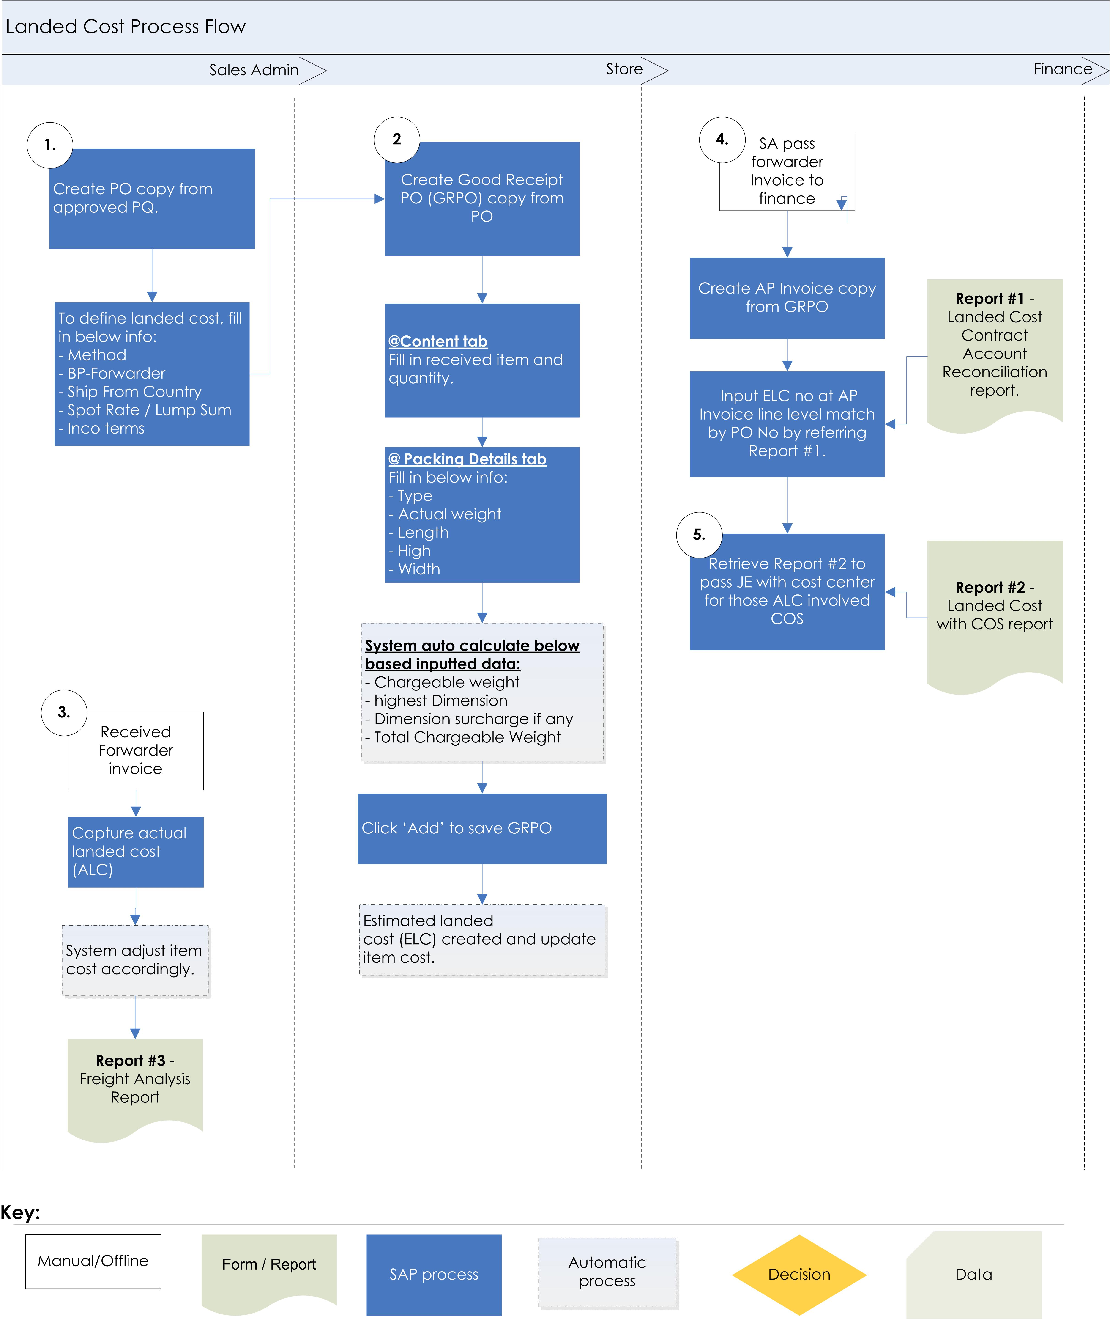
Automation will start from here.

- When store create GRPO copy from PO, below information will auto populate from PO except ‘Total Chargeable Weight’ and Spot Rate/Lump Sum need to input upon receiving.

Create below list of UDF in marketing document header level:
Method | Courier | UDF (Drop down list >> Courier, Forwarder, Spot Rate, Lump Sum, None)
BP – forwarder (UDF) | DHL Express | UDF (Choose From List - BP List)
Ship From Country | UK | UDF (from country) – pick from BP Master default ship to address country code
Zone | 1 | UDF - FS based zone table
Total Chargeable Weight | 227 | System calculate from GRPO grid
Spot Rate / Lump Sum | (Amount column) | UDF – Mandatory if Method = Spot Rate / Lump Sum
Inco terms | EXW | UDF – Default pick from BP Master Inco terms UDF based on select BP – forwarder.

Cost Calculation Method

Method = Courier - If Method selected “Courier”, the following formula will be applied:

[Courier Table + Fuel Surcharge Table + Inco Table + Dimension Surcharge table + Fuel Surcharge x Total Dimension Surcharge]

Method = Forwarder - If Method selected “Forwarder”, the following formula will be applied:

[Forwarder Table + Inco Table + Dimension Surcharge table]

Method = Spot Rate - If Method selected “Spot Rate”, the following formula will be applied:

[GRPO Sport Rate UDF * GRPO Weight (kg)] + Fuel Surcharge Table + Inco Table + Dimension Surcharge table + Fuel Surcharge apply to Dimension Surcharge

Method = Lump sum - If Method selected “Lump sum”, the following formula will be applied:

[GRPO Sport Rate UDF] (considered as lump sum freight amount) (for sea freight)

Method = None - If Method selected “None”, no landed cost document will be created.

- Formula of Volumetric weight:

Formula of Volumetric weight:
Courier >> Length x height x width / 5000

Forwarder >> based on country code
Length x height x width / 6000
Length x height x width / 3000

- Below will be new tab – Packing Details to be created for Store to input Actual Weight and dimension by packaging type.

Packing Details (after Attachment tab) – will be at Grid Format as below:

No | Packaging  Type | Actual Weight | Chargeable weight | Length | High | Width | Highest Dimension | Dimension Surcharge
1 | Pallet | 75 | 156 | 120 | 50 | 130 | 130 | 85
2 | Pallet | 65 | 65 | 30 | 125 | 40 | 125 | 40
3 | Carton | 3 | 6 | 20 | 30 | 50 | 50 | 0

Fields Explanation:
No | Field Name | Control type | Business Rules
1. | Packaging type | Drop Down | Options: (can be add in future)  - Pallet  - Carton  - Box
2. | Actual Weight | Text Box | User Input
3. | Chargeable Weight | Text Box | System auto pick from either Actual weight or Volumetric weight, whichever is higher.  Formula of Volumetric weight:  Courier >> Length x height x width / 5000  Forwarder >> based on country code  Length x height x width / 6000  Length x height x width / 3000
4. | Length | Text Box | User Input
5. | Height | Text Box | User Input
6. | Width | Text Box | User Input
7. | Highest Dimension | Text Box | System auto pick from either Length or High or Width whichever is higher.
8. | Dimension Surcharge | Text Box | - One time charge per pallet, if one pallet exceeds both weight and dimension, then charge one time only whichever is higher between weight surcharge or dimension surcharge.  - Charge only if exceed the maximum.  - If Extra Charge in Surcharge table = Yes, both Weight and Dimension exceed maximum, Dimension surcharge will be Weight surcharge + Dimension

- Calculation for the cost and add into Landed Cost. This calculation will be hidden to user and auto calculates backend then saves into Landed Cost.
Method : Forwarder
Exchange rate : 2.1
 | Minimum | Flat | Flat Amount | Whichever is higher | Plus Basic | After convert SGD
Freight | 20.00 | 1.20 | 42.00 | 42.00 | 0.00 | 88.20
Fuel | 0.00 | 1.50 | 1.50 | 52.50 | 0.00 | 110.25
Handling | 20.00 | 0.20 | 7.00 | 20.00 | 32.00 | 109.20
Export Fee | 15.00 | 0.00 | 0.00 | 15.00 | 0.00 | 31.50
X-Ray | 8.00 | 0.09 | 3.15 | 8.00 | 0.00 | 16.80
Local Handling | 60.00 | 0.20 | 7.00 | 60.00 | 0.00 | 60.00
 |  |  |  |  |  | 415.95
Insurance* | = USD 1000 x 1.1 x 0.0025 = USD 2.75 |  |  |  |  | 3.85
 |  |  |  |  |  | 419.80
Dimension | = 80 |  |  |  |  | 80.00
Total Estimated Landed Cost to be created |  |  |  |  |  | 499.80

Total Estimated Landed Cost of example in above = SGD 499.80

The Breakdown cost will be as below in SAP screen:
Insurance: 3.85
Freight Charges: 415.95 + 80.00 = 495.95

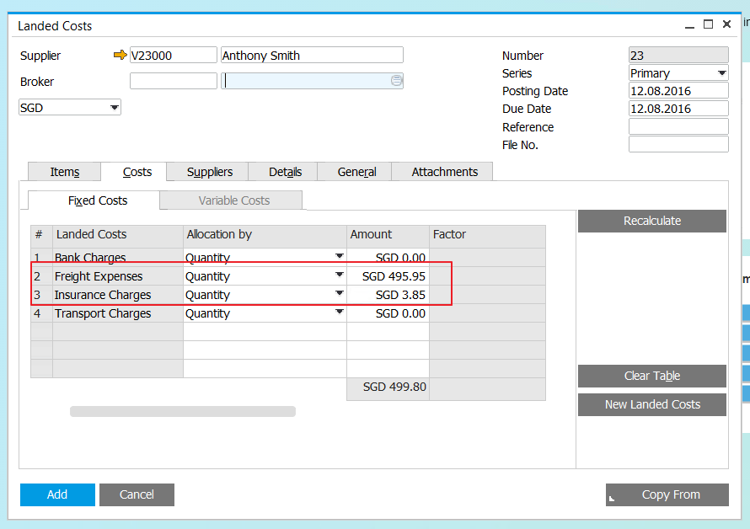

Reports

Report #1 – Landed Cost Contract Account Reconciliation Report

Column in reports:
BP | PO# | GRPO# | ALC  Required? | ELC# | ELC Amount  (Credit) | ALC# | AP  Inv # | Inv Amount  (Debit)

Requirement:
- This is report is for finance to do reconciliation for the landed cost.
- Finance has to input ELC no at AP Invoice line level match by PO no. if cancel invoice, finance to duplicate and amend accordingly.
- Filter by : BP Range, ELC #, PO#, ALC Required, Posting Date Range

Report #2 – Landed Cost with COS account report

Column in reports:
BP | PO# | GRPO# | ALC  Required? | ELC# | ELC Amount  (Credit) | ALC# | AP  Inv # | Inv Amount  (Debit)

Requirement:
- This is report is for finance to pass JE by cost center for those ALC posted to Cost of good sold account.
- Finance has to input ELC no at AP Invoice line level match by PO no. if cancel invoice, finance to duplicate and amend accordingly.
- Filter by : BP Range, ELC #, PO#, ALC Required, Posting Date Range

Report #3 – Freight Percentage

Column in reports:
Forwarder/  Courier  Name | Weight | GRPO# | GRPO Amount | ELC-Freight  Charge | ELC Freight% | ALC# | ALC Freight Charge | Actual Landed Cost Amount | ALC% | AP Invoice#
 |  |  |  |  | ELC - Freight Charge / GRPO value * 100 |  |  | Total ALC | Total ALC / GRPO value * 100

Requirement:
- Filter by GRPO Date Range, Percentage above [>], Supplier Code Range, Forwarder Range.
- Show those with % above the given parameter.

